Washing Dishes Checklist
1. | put the plug in the sink | 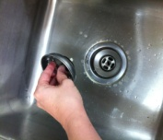
2. | fill the sink with WARM water | 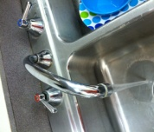
3. | squeeze a small amount of soap into the WARM water | 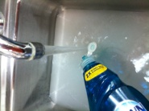
4. | put the dirty dishes into the soapy water | 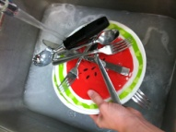
5. | wet the sponge before scrubbing each dish | 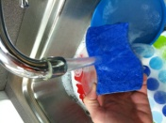
6. | turn the water off while scrubbing the dishes | 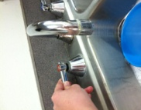
7. | place cleaned dishes in the empty CLEAN sink | 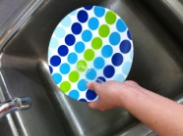
8. | when finished washing, pull the plug and rinse it off | 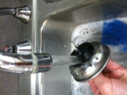
9. | rinse the sponge and squeeze all the water out before placing it on top of the silver box | 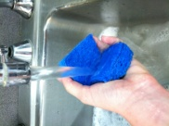
10. | place the drying mat on the counter | 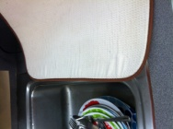
11. | rinse the dishes with WARM water | 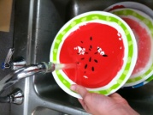
12. | shake the dish before placing it on the dry mat | 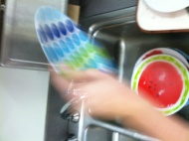
13. | dry all the dishes | 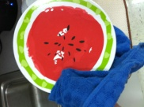
14. | put the dishes away | 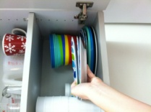
15. | put the drying mat back where it belongs | 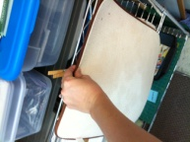
16. | wipe the sink using paper towel | 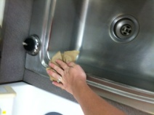
17. | use a wet wipe to clean the counters and white stove top | 