Vacuuming the Rugs Checklist
1. | put the vacuum next to the purple rug | 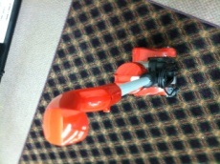
2. | unwrap the cord | 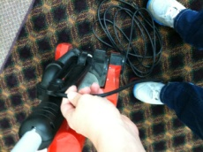
3. | plug the cord into the outlet | 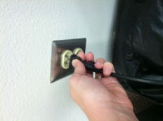
4. | move items off of the purple rug | 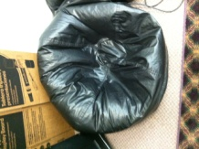
5. | vacuum the entire rug | 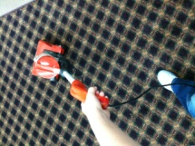
6. | move items back onto the purple rug | 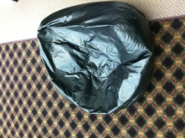
7. | unplug the cord by grabbing close to the outlet | 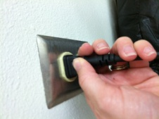
8. | put the vacuum next to the blue rug | 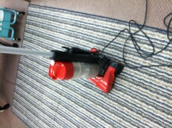
9. | plug the cord into the outlet | 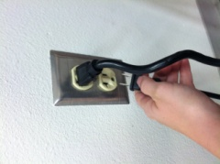
10. | move items off of the blue rug | 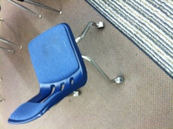
11. | vacuum the entire rug | 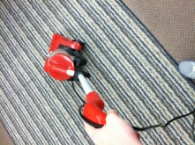
12. | move items back onto the blue rug | 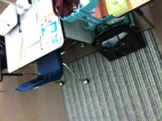
13. | unplug the cord by grabbing close to the outlet | 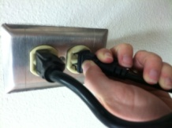
14. | wrap the cord up and put the vacuum away | 