McDonalds Menu Name: ______________________

Meals – come with a DRINK and FRIES!
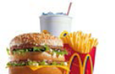 #1 Big Mac Meal $ 5.99 MED LARGE
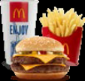 #2 Quarter Pounder Meal $ 5.99 MED LARGE
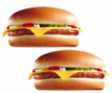 #4 2 Cheeseburger Meal $ 5.19 MED LARGE
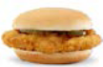 #8 Southern Style Ckn Meal $ 5.99 MED LARGE
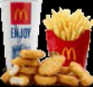 #10 10 pc Chkn McNuggets $ 5.49 MED LARGE
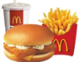 #11 Filet-o-fish Meal $ 5.59 MED LARGE

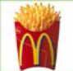French Fries Sauce: Ketchup Barbeque Honey Mustard
Med. $ 2.09
Large $ 2.59

Drinks Desserts
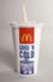Med. $ 1.79 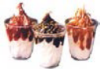Sundae $ 1.39 Strawberry Chocolate Carmel
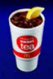Large $ 2.09 Cones $ 1.09 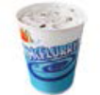McFlurry $1.69 M&M Oreo Reeses

My Order
_________________________________ $ _____________________
_________________________________ $ _____________________
Sub Total $ _____________________ X .07 = . ___ ___ Tax Total

Sub Total $ __________+ Tax Total ___________ = Final Total $ _____________________

