Empty the Trash Checklist
1. | take the small bags out of the 3 SMALL trash cans | 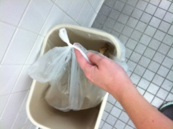
2. | put the bags into the BIG trash can | 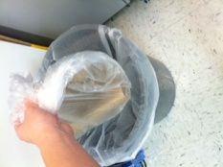
3. | put the new trash bags in each trash can | 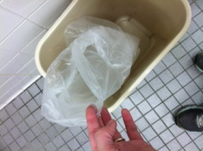
4. | twist the corner of the plastic trash bag | 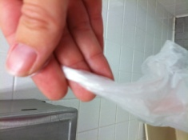
5. | wrap the twisted plastic around your 2 fingers | 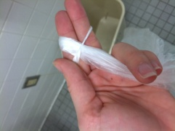
6. | slide it through the hole and pull tight | 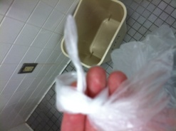
7. | once you have a knot, stretch the trash bag around the edges of the trash can | 