Dust the Bookshelves Checklist
1. | grab the blue glove and yellow dust spray | 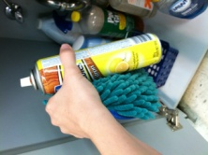
2. | shake the can | 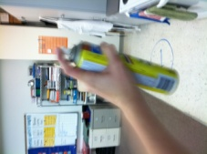
3. | spray the blue glove ONE time only | 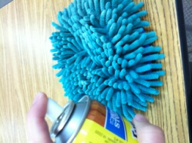
4. | put the spray away | 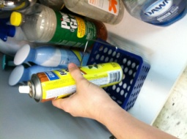
5. | remove items off the top of the bookshelf | 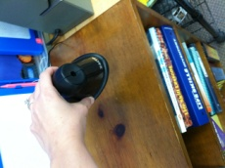
6. | wipe the top of the bookshelf with the blue glove | 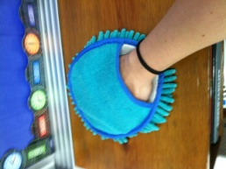
7. | wipe around the items on the shelves below | 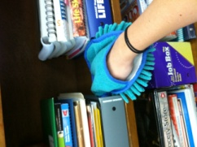
8. | put items back where they belong | 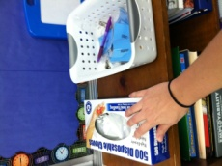
9. | remove items off of the top of the BLACK bookshelves near the tv | 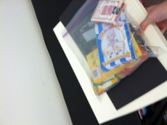
10. | wipe the top of the bookshelf with the blue glove | 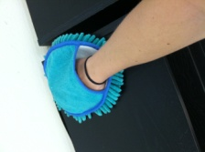
11. | wipe around the items on the shelves below | 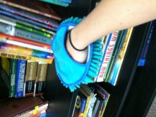
12. | put items back where they belong | 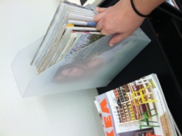
13. | put the blue glove and spray back under the sink | 