Clean the Windows Checklist
1. | grab the squeegee, purple cloth and window spray | 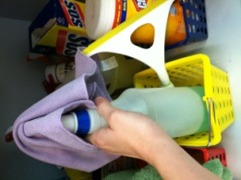
2. | spray 2 times on the window to the office | 
3. | use the squeegee and reach as high as you can | 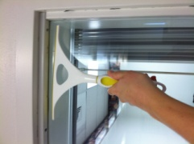
4. | push the squeegee against the glass and pull down to the bottom of the glass | 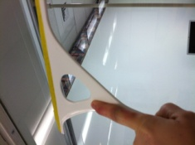
5. | push the squeegee against the glass and down at least 4 times | 
6. | wipe the edges of the window, window sill and any wet spots on the window | 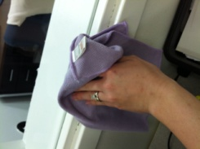
7. | move the blinds to the side of the window | 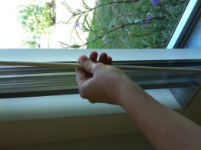
8. | spray 2 times on the window next to the computers | 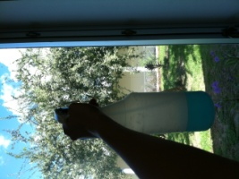
9. | use the squeegee and reach as high as you can | 
10. | push the squeegee against the glass and pull down to the bottom of the glass | 
11. | push the squeegee against the glass and down at least 4 times | 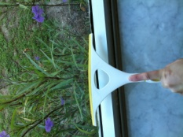
12. | wipe the edges of the window, window sill and any wet spots on the window | 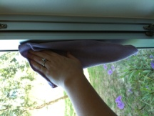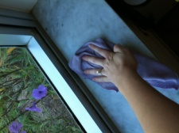
13. | close the blinds | 
14. | spray 1 time on the window on the door INSIDE | 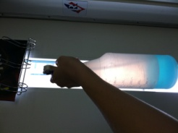
15. | wipe the window with the purple cloth | 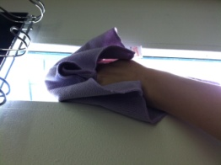
16. | spray 1 time on the window on the door OUTSIDE | 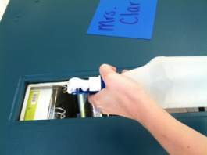
17. | wipe the window with the purple cloth | 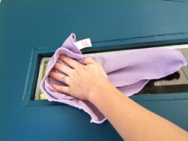
18. | put the spray, squeegee, and purple cloth under the sink | 