Clean the Bathroom Checklist
1. | lift the toilet seat | 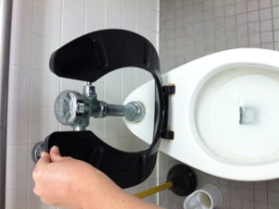
2. | sprinkle a little bit of the COMET into the toilet bowl | 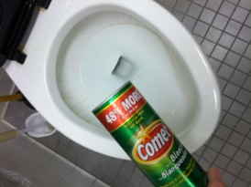
3. | using the scrub brush, scrub the toilet ring | 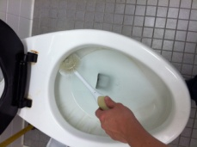
4. | when you are finished, tap the scrub brush against the toilet and put it back where it belongs | 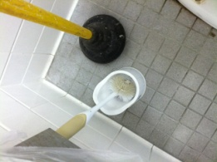
5. | flush the toilet and put the seat back down | 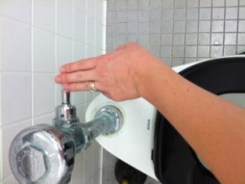
6. | grab the blue sponge and white spray bottle for the sink | 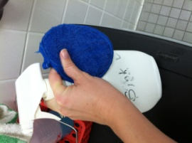
7. | spray 4 times on each corner of the sink | 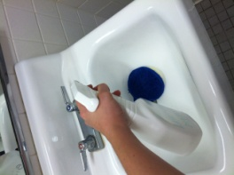
8. | wet the sponge | 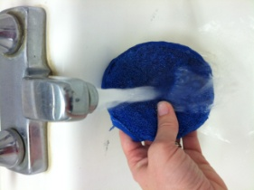
9. | scrub the sink using the sponge | 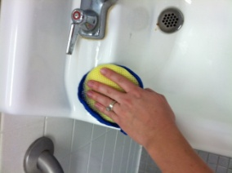
10. | rinse and scrub the sink 2 more times | 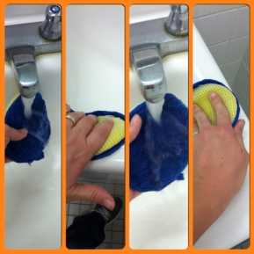
11. | rinse the sponge and squeeze out the water | 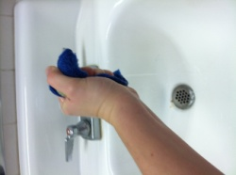
12. | put the sponge and white spray bottle back where they belong | 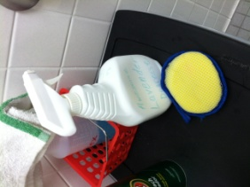
13. | dry the sink using paper towel | 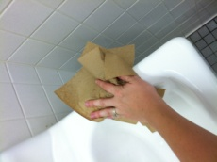
14. | grab the white cloth and blue spray for the mirror | 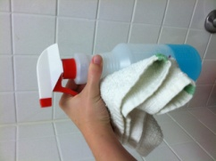
15. | spray the mirror 2 times | 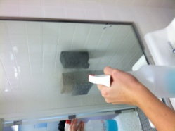
16. | wipe the mirror and the edges | 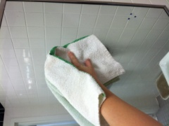
17. | put the blue spray and cloth back where they belong | 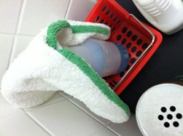
18. | turn off the light | 